COMPUTATIONAL AND EXPERIMENTAL INVESTIGATION OF SUBSONIC FLOW OVER A SAWTOOTH NOTCHED DELTA WING

Jayanta Sinha1, J. K. Jain2,Sadaf Rakhshan3, Mihika Gupta4, Alexandra Arnold Massey5

*1, 2, 3, 4, 5Amity Institute of Aerospace Engineering, Amity University Uttar Pradesh, Noida,*

*1*[*jsinha1@amity.edu*](mailto:jsinha1@amity.edu)*, 2*[*jkjain@*](mailto:konark.arora@gmail.com)*amity.edu, 3*[*sadafneyam@gmail.com*](mailto:arnabbhattacharya6@gmail.com)*, 4*[*mihika97gupta@gmail.com*](mailto:paulam.saha1997@gmail.com)*, 5*[*alexandrashivangi@gmail.com*](mailto:swarn1997@gmail.com)

**ABSTRACT**

This paper is concerned with study of low subsonic flow characteristics over a sawtooth delta wing. A Sawtooth delta is formed by inducing saw shaped notches to the leading edges of a delta wing. Qualitative and quantitative analysis were performed experimentally. Static pressure measurement and path lines were obtained from CFD analysis at different angles of attack for different span and chord wise locations on top surface of the delta wing. The flow field data obtained with saw tooth delta wings have also been compared with a simple delta wing of comparable dimensions. Saw tooth delta aerodynamic parameters were found similar or higher than its simple delta equivalent. The presence of notches created additional local vortices which adds up to the Primary vortex and therefore increases the total intensity of Vortex. The high angle of attack upto 10 $°$ has been reported and the research has observed the change in aerodynamic pattern at both positive and negative angle of attacks.

**Keywords—** Sawtooth Delta wing, vortex lift, Vortex bursting, pressure coefficients, CFD.

**I. INTRODUCTION**

Study of flow field on the Delta wings has been of interest to researchers due to its application towards design of highly maneuverable aircrafts. The development of highly maneuverable aircraft, missiles, and reusable launch vehicle has generated interest in the study of delta wings due to possible advantage of better stability and control characteristics and increasing Lift while keeping Drag at minimum. Although performance of Delta wings is highest at high Supersonic speeds, but critical aspects of a flight like Take-Off and Landing are performed at low subsonic speeds and hence analyzation of subsonic flow is critical. The flow over delta wings generates separation induced leading edge vortex flow [1] which will depend on various factors like slenderness, sweep angle, shape of leading edge, angle of attack, free stream velocity, Reynolds number etc. [2]. At high angles of attack [3], the onset of flow separation might lead to formation of vortex flow which can have crucial effect on the performance of aircraft. The vortex lift is the method by which highly swept wings like delta wings produce lift at high angles of attack. Therefore the details of flow field obtained will be of immense use to the designer. Hsu and Liu [4] carried out the numerical simulation of delta wing for a sharp edged delta wing. Polhamus [5] reported that the major problem associated with the prediction of the lift of sharp-edge delta wings is the calculation of the so-called vortex lift associated with the leading-edge separation spiral vortex. This problem arises primarily from the difficulty in determining with sufficient accuracy the strength, shape, and position of the spiral vortex sheet.

In the case of wings having sharp, highly swept leading edges like delta wings, the leading-edge separation vortex phenomenon occurs at subsonic speeds. However, the separation does not destroy the lift as in the case of low sweep wings; instead, it forms two vortices which are (nearly) parallel to the wing edges. Generally Vortex lift needs two conditions firstly high leading edge sweep angle and secondly high angle of attack. It has been shown by Hemsch and Luckring [6] that increasing leading-edge sweep for slender delta wing decreases vortex lift and leading edge vortex strength. Further experimental and numerical analysis over different delta wings has been reported by Nath et al. [7], Henning et al. [8], Gurusul et al. [9] etc. Flow visualization has been aptly presented by Channa et al. [10], Lowson et al. [11] and others. The flow field patter over a simple delta wing is given in fig 1.

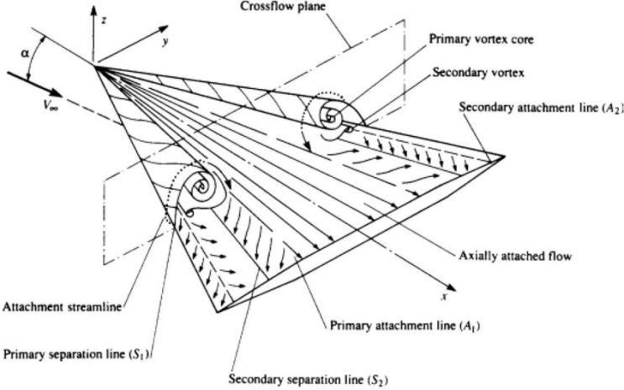

Fig. 1: Flow structure over a delta wing.

In the present case both the computational and experimental analysis were undertaken over a sawtooth delta wing model at very low velocity of 21m/s. Static pressure were measured over the chord of the double delta wing and in the span wise direction at x/C = 0.57 and 0.75. In the experimental analysis total of 11 pressure tapings were used to measure static pressure distribution over the delta wing model. Oil flow visualization has also been carried out on the same model to understand the flow behavior over the saw tooth delta wing. Aerodynamic characteristics for angles of attack ranging from -5° to 15° at subsonic speeds were recorded. Similar data has been obtained through numerical simulation. Comparison has been made between the static pressure distribution obtained through experiments and numerical simulation along with the streaklines obtained from the oil flow visualization. A good match has been obtained that validates the numerical work.

**II. EXPERIMENTAL ANALYSIS**

A fabricated model can be seen in figure 2 and its mounting in the subsonic wind tunnel can be seen in figure 3.

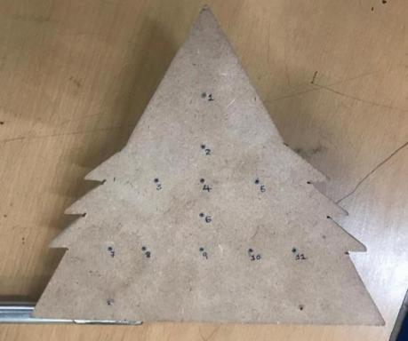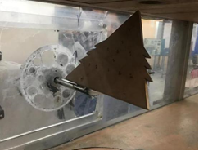

Fig. 2: Fabricated MDF-wood model with pressure tapings Fig.3 Model mounted in wind tunnel

1. **STATIC PRESSURE MEASUREMENT**

Wind tunnel testing of the fabricated sawtooth delta wing model was carried out at different angles of attack in the subsonic open wind tunnel of the Aerospace laboratory of Amity University, Noida. The test section area was 30cm* 30cm or 1 ft. *1 ft. with maximum subsonic air speed of 21 m/s. The readings of total and static pressures at 11 discrete points with tapings located on the model were recorded at different angles of attack using an ethanol manometer. Pressure coefficients at each tapings were calculated using the Bernoulli’s equation. Cp was found using:



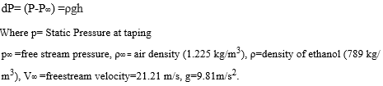

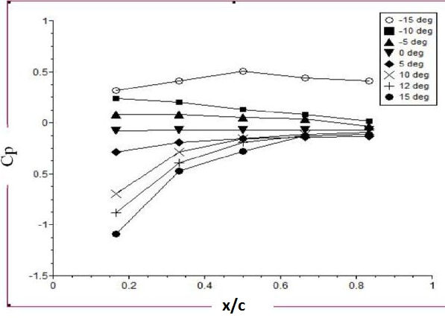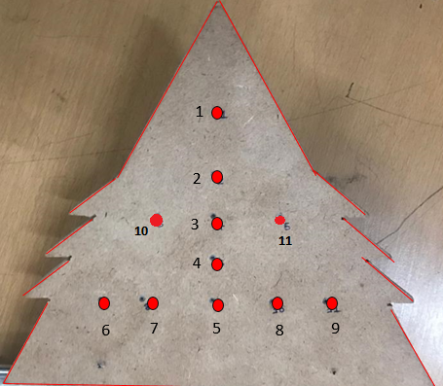

Fig. 4: Pressure tapping arrangements Fig. 5: Cp distribution along the chord of the delta wing

Readings were obtained in the chordwise location at 5 pressure taping numbered 1-5, shown in the figure 4, located on the upper surface of the model. Pressure coefficient distribution along the chord wise location can be seen in figure 5. It can be seen at 15° angle of attack pressure coefficient is more negative near the tip of the delta wing, whereas it is positive at negative angle of attack. With decrease in angle of attack Cp rises gradually. Similarly, for a given angle of attack, Cp rises as we go from the tip of the delta wing to its base. This means that pressure is increasing as we move along the chord towards the trailing edge, which clearly suggests that lift decreases as we move towards the trailing edge and most of the lift is generated near the leading edges and middle part of the wing, where strong vortex generation takes place.

Similar results are found in CFD also. As we increase the angle of attack, the vortex travelling backward towards the trailing edge and becomes much stronger leading to a lower pressure on the surface.

Positions 1,2,3,4 and 5 correspond to the values in graph: 1, which shows chord wise variation of Cp at various Angles of Attack.

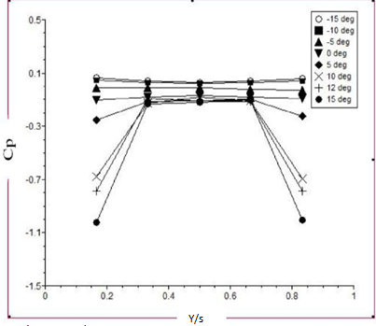

Fig. 6: Cp distribution along the span of the delta wing

Readings were obtained in the spanwise location at 5 pressure taping numbered 6-7-5-8-9, shown in the figure 4, located on the upper surface of the model. Position 5 is a common location in both spanwise and chordwise plot. Cp, shown in figure 6, increases and then decreases as we move along the span of the wing from port to the starboard side forming a parabolic curve.

This means that pressure on the upper surface is lowest near the wing edges and increases in the middle of the wing. We see that the Cp values of test data are more negative at 15° angle of attack, because the vortex strength increases leading to higher lift at higher angles of attack. The distribution of pressure coefficient is in positive for -15° angle of attack.

**III. COMPUTATIONAL ANALYSIS**

* 1. **Design**

ANSYS Space Claim Design Modeler was used for making the 3-D Delta wing model of our desired specifications shown in figure 3. The Model was then meshed and simulated in the ANSYS Fluent 19.0

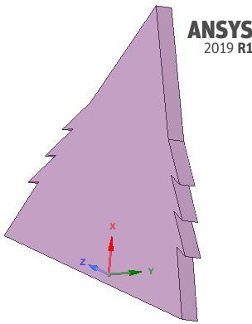

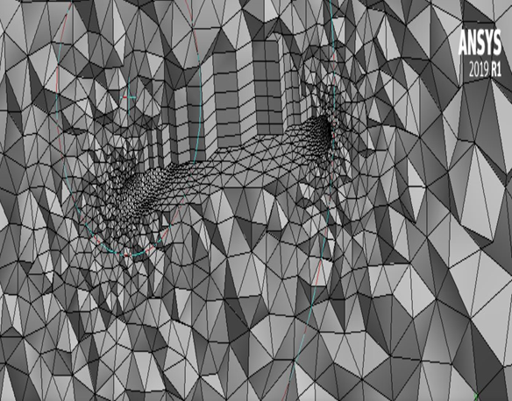

Fig. 7: 3D model in ANSYS Space claim Fig. 8: Cut view of Numerical Grid (Mesh)

**b) Solver set-up and Grid generation**

3-Dimensional Steady State Simulation was performed over the model. Fluid chosen for the setup was air (ρ=1.225 kg/m3) and velocity was set to 21m/s at the inlet, which is synonymous to the subsonic Wind Tunnel speed available at Amity University Aerospace Lab, Noida. Pressure Based solver was used in accordance with the subsonic incompressible flow to compute the results, there is no dependence of pressure on density and temperature. As a result, pressure based solvers are an optimal choice for better accuracy. Since this type of solver derives the pressure using a pressure correction technique, ipso facto, the Semi-Implicit Method for Pressure Linked Equations- Consistent was used. Flow viscosity was set to Sutherland with a temperature of 300K for better accuracy. K-omega (SST) Shear Stress Transport model was used to account for any minor turbulent effects at even low speeds. Satisfactory results were obtained.

The flow conditions were then set on the domain of the Saw Tooth delta wing geometry, which had been imported from ANSYS Space claim Modeler (where the geometry was created along with a domain of 4x6x4 m3). An attempt was made to mesh the geometry using a structured grid, however, due to the complex geometry nature, this attempt was abandoned and thereafter, an unstructured Tri-Tet mesh with good orthogonal quality was used. Mesh was made more refined over the upper and lower surfaces where boundary layer gradients were to be captured. Boundary conditions were given for the inlet and outlet and solution was run until 25000 iterations were completed. The number of iterations was not too large, however for the purposes of our research, sufficient amount of convergence had been achieved Validation of the numerical analysis was performed based on the data provided by B. Nath et al. [4].

For Post Processing, contours of velocity, vorticity and static pressure have been reported in the paper. Planes were created at three different locations along the chord to present the variation of the vorticity as we go along the chord wise directions (15%), (25%) and (95%).Vorticity patterns along Y –axis are illustrated below with the help of contour plots. Comparative analysis is done for oil flow patterns obtained from CFD and experimentation.

**IV.RESULTS AND DISCUSSIONS**

* 1. **Post processing results**

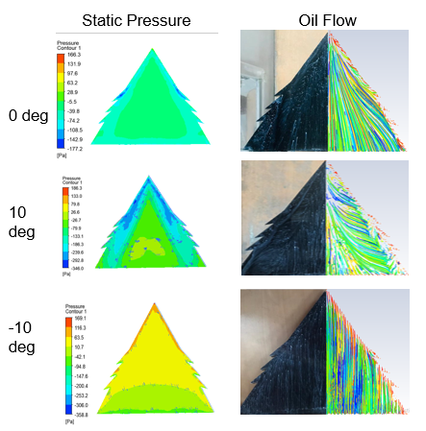

Fig: 9: Contours of Static Pressure and Oil Flow analysis

In figure 9, left column shows static pressure contours on upper surface of the wing. The pressure values are found the most negative near to and above the leading edges where the vortex formation essentially takes place.

High negative pressure values are found near 25 to 50 percent chord, where the location of Saw Tooth lies.

Pressure values become increasingly negative as we increase the AoA. Also, high positive pressures are noted on the upper surface at negative angles of attack.

Towards the right column of the figure, we see the oil flow patterns from experiment and CFD. The patterns from both analyses complement each other with high similarities in locations of the attachment lines, axially attached flows and starting location of the primary vortex over the upper surface of the wing. Satisfactory coherence is established between the both.

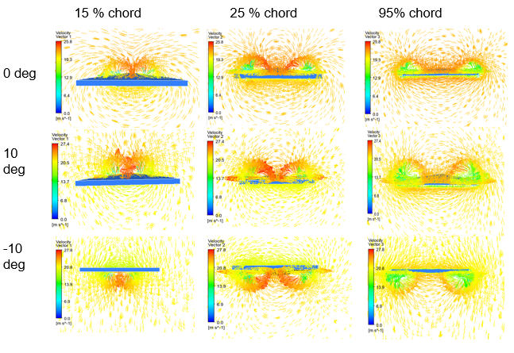

Fig: 10 Vorticity contours at various Chord wise Locations

The vorticity patterns obtained from CFD Post Processing clearly show the formation of vortex over the upper surface of the Delta Wing. From the numerical values obtained, it can be very precisely determined that the vorticity values increase as we go from 0 to 10 deg AoA. Also, it is observed that at negative angles of attack, the vortex formation takes place on the lower surface of the wing. If we analyze the Vorticity pattern along the chord wise location then we can see the symmetrical vortex pattern and the strong vortices lies near the leading edge of the wing. This pattern is pretty consistent from -10° to 10° angle of attack.

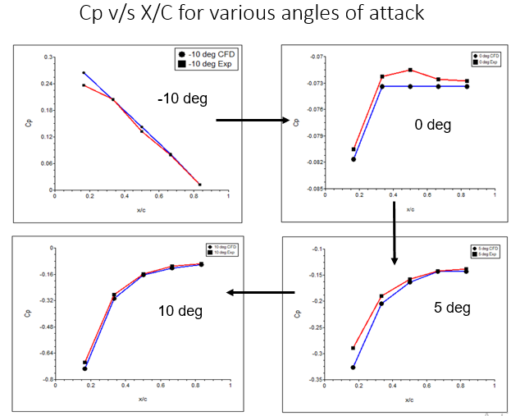

Fig: 11 Cp v/s X/c for various AoA’s

Figure 11 gives the comparison of the experimental and numerical Cp distribution over the delta wing in the chord wise direction at different angle of attack. Blue line gives the numerical Cp distribution, whereas Pink line gives the experimental Cp distribution. We can see a very good match in the pattern. Further investigation of the pressure distribution in the chord wise direction at various angles of attack has also given important details of the pressure variation that increases from the tip of the delta wing to its base. Cp is the most negative near 0.25 percent of the chord and increases at a steady rate as we move along the chord of the wing towards the trailing edge, forming almost a parabolic curve. It also signifies that the formation of vortex and occurrence of negative pressures takes place near 25 to 50 percent of chord where the saw tooth lies, thereby signifying the use of saw tooth. Cp values become increasingly negative as we move from -10 to 10 deg AoA.

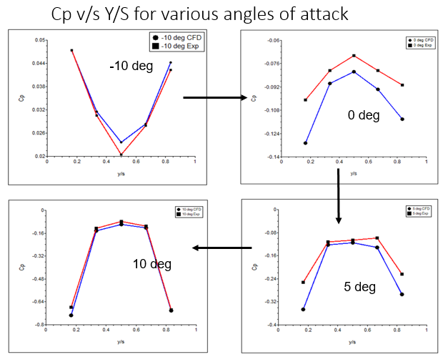

Fig: 12 Cp v/s Y/s for various AoA’s

Figure 12 gives the comparison of the experimental and numerical Cp distribution over the delta wing in the span wise direction at different angle of attack for x/c=0.75

For CFD analysis we observe that the Cp first increases and then decreases as we move along the span of the wing from port to the starboard side forming a parabolic curve. In the wind tunnel experiment we see the trend of Cp first increasing and then decreasing as we move along the span of the wing forming near parabolic curve. This means that pressure is less on the wing tips and higher in the middle, complementing our observation that vortices are formed along the tips of the wing, near to the saw tooth location. Cp values become increasingly negative as we move from -10 to 10 deg AoA

**V. CONCLUSIONS**

We have observed the Cp distribution in the chord wise location and spanswise location at different angle of attack. Vorticity values were obtained from the numerical data. The value of numerical Cl increases with the increase of angle of attack but so does the value of Cd due to increasing induced drag due to the formation of vortices. The vortices are formed at the leading edge extension that is the saw tooth region of the delta wing and travels along the chord of the wing towards the trailing edge as we increase the angles of attack. The strength of the vortices increases as we increase the angle of attack. We see that negative lift is generated for negative angles of attacks as the delta wing has no camber to generate lift. We see that the values of Cp become more negative on the upper surface of the wing as the angles of attack are changed to more positive. The velocity increases on the upper surface in magnitude as we increase the angle of attack. Also the velocity vectors start to change directions in accordance to the flow in the vortices. From the oil flow experiment it was validated that no vortices are formed for 0° angles of attack. For -10° the vortices are formed on the lower surface. For 5°and 10° angles of attack vortices are formed over the upper surface of the wing. The oil flow analysis shows that the attachment line/ the primary vortex line becomes stronger with increase in angle of attack and shows the secondary and primary vortex regions distinctly. Attachment and separation lines are identified clearly. The flow keeps on circulating at the edge of the trailing edge. The CFD and wind tunnel data also has shown good match.

**VI. FUTURE SCOPE**

Analysis of the flow using Laminar and Inviscid model schemes can be performed. Also supersonic flow simulation over the model can be done.

**REFERENCES**

1. R. E. Muir, A. Arredondo-Galeana, and I. M. Viola, “The Leading-edge Vortex of swift wing-shaped delta wings”, Royal Society of Open Science, Vol. 4, No. 8, 2017.
2. Verhaagen, N. G., Jenkins, L. N., Kern, S. B., and Washburn, A. E., “A study of the vortex flow over a 76/40- degree double-delta wing”, AIAA Paper 95-0650, 1995.
3. M. Ozgoren, B. Sahin, D. Rockwell, “Vortex Structure on a delta wing at high angle of attack”, AIAA Journal, Vol. 40, No. 2, pp. 285-292, 2002.
4. C. H. Hsu, and C. H. Liu, “Investigation Of Vortex Breakdown On Delta Wings Using Navier-Stokes Equations”, Fluid Dynamic Research, Vol. 10, Issue 4-6, pp. 399-408, 1992.

**[5]**E. C. Polhamus, “A Concept of the Vortex Lift of Sharp-Edge Delta Wings Based on aLeading-Edge-Suction Analogy”, NASA TN D-3767, 1966.

1. M. J. Hemsch; J. M. Luckring, “Connection between leading-edge sweep, vortex lift, and vortex strength for delta wings”, Journal of Aircraft, Vol. 27, Issue-5, pp. 473-475, 1990.
2. B. Nath, S. Das, and J. K. Prasad, “Flow-field Study on a 65-deg blunted delta wing”, National Conference on Wind Tunnel testing, India, March 2009.
3. A. Henning, M. Rutten, C. Wagner, and M. Raffel, “A stereo PIV investigation of a vortex breakdown above a delta wing by analysis of vorticity field”, AIAA 2005-4908.
4. Gursul I, Wang Z and Vardaki E., “Review of Flow Control Mechanisms of Leading-Edge Vortices”, AIAA paper 2006-3508.
5. R. Channa and P. R. Viswanath, “Pressure sensitive paint measurements in blow down wind tunnel”, Journal of Aircraft, Vol.42, No.4, pp.908-915, 2005,
6. M. V. Lowson., “Visualization measurements of vortex flows”, JOURNAL OF AIRCRAFT , Vol. 28, No. 2, 1991.